7.0.2 Editors - 3D View - Mesh Object - Edit Mode - Vertex Context Menu
Detailed table of content 1
Vertex Context Menu 4
Subdivide 4
Extrude Vertices 5
Bevel Vertices 6
Make Edge/Face 8
Connect Vertex Path 8
Connect Vertex Pair 9
Push/Pull 9
Shrink/Fatten 9
Shear 10
Randomize Vertices 11
Smooth Laplacian 12
Snap Vertices 12
Last Operator Snap 12
Mirror Vertices 13
Merge Vertices 13
Split 14
Separate 14
Dissolve Vertices 14
Delete Vertices 15

Detailed table of content

Detailed table of content
Detailed table of content 1
Vertex Context Menu 4
Subdivide 4
Last Operator Subdivide 4
Number of Cuts 4
Smoothness 4
Create N-Gons 4
Quad Corner Type 4
Fractal 5
Along Normal 5
Random Seed 5
Extrude Vertices 5
Last Operator Extrude Only Vertices and Move 5
Move X Y Z 5
Orientation 5
Constraint Axis 5
Proportional editing 5
Proportional Falloff 5
Proportional Size 5
Connected 5
Projected(2D) 5
Bevel Vertices 6
Last Operator Bevel 6
Offset 6
Width type 6
Vertex only 6
Clamp Overlap 6
Loop Slide 6
Mark Seams 6
Mark Sharp 6
Harden Normals 6
Segments 6
Profile 7
Material 7
Miter Type 7
Outer Miter 7
Sharp 7
Patch 7
Arc 7
Inner Miter 7
Sharp 7
Arc 7
Spread 7
Face Strength Mode 8
None 8
New 8
Affected 8
All 8
Intersection type 8
Make Edge/Face 8
Connect Vertex Path 8
Connect Vertex Pair 9
Push/Pull 9
Last Operator Push/Pull 9
Factor 9
Proportional editing 9
Proportional Falloff 9
Proportional Size 9
Connected 9
Projected(2D) 9
Shrink/Fatten 9
Last Operator Shrink/Fatten 10
Offset 10
Offset Even 10
Proportional editing 10
Proportional Falloff 10
Proportional Size 10
Connected 10
Projected(2D) 10
Shear 10
Last Operator Shear 10
Offset 10
Shear Axis 10
Axis 11
Axis Ortho 11
Orientation 11
Proportional editing 11
Proportional Falloff 11
Proportional Size 11
Connected 11
Projected(2D) 11
Randomize Vertices 11
Last Operator Randomize 11
Amount 11
Uniform 11
Normal 11
Random Seed 12
Smooth Laplacian 12
Last Operator Laplacian Smooth Vertex 12
Number of Iterations 12
Lambda Factor 12
Lambda Factor in border 12
Smooth Axis 12
Preserve Volume 12
Snap Vertices 12
Last Operator Snap 12
Offset 12
Mirror Vertices 13
Last Operator Mirror 13
Orientation 13
Constraint Axis 13
Proportional editing 13
Proportional Falloff 13
Proportional Size 13
Connected 13
Projected(2D) 13
Merge Vertices 13
At Center, At Cursor, Collapse 13
Last Operator Merge 14
Type 14
UV's 14
By Distance 14
Last Operator Merge by Distance 14
Merge Distance 14
Split 14
Separate 14
Selection 14
By Material 14
By Loose Parts 14
Dissolve Vertices 14
Last Operator Dissolve Vertices 15
Face Split 15
Tear Boundary 15
Delete Vertices 15

Vertex Context Menu

Call this menu with double right click in the 3D viewport. You need to be in Edit mode with a Mesh object. And in selection mode Vertice.
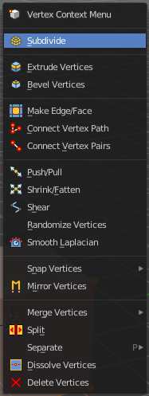
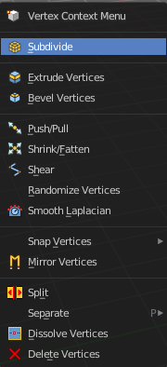
Select geometry to reveal all content.

Subdivide
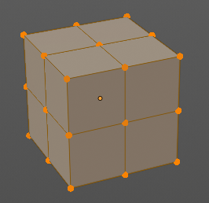
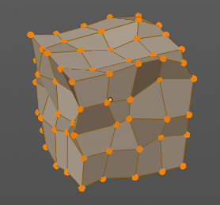
Subdivide divides the selected edges. It subdivides the involved faces too, and can create new vertices.
A more unknown functionality is that it can also randomize the result with the Fractal slider in the Last operator panel.

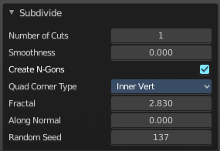
Last Operator Subdivide

Number of Cuts
The number of cuts defines the amount of subdivisions.

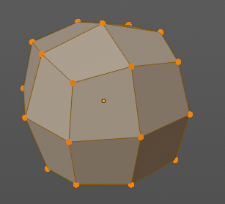
Smoothness
This value defines how smooth the subdivision result is. From flat to bent.

Create N-Gons
Create N-Gons if required. Else subdividing N-Gons creates Tris.

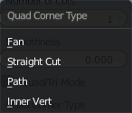
Quad Corner Type
Adjust the corner type.

Fractal
Randomize the selected vertices.

Along Normal
When randomized, this value defines how strong the subdivision follows the normals of the initial vertices.

Random Seed
Randomizing value for fractal randomizing.

Extrude Vertices
Extrudes out the selected vertices by moving the mouse.

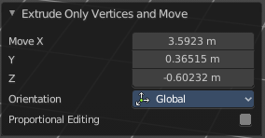
Last Operator Extrude Only Vertices and Move

Move X Y Z
The coordinates for the extruded geometry.


Orientation
Choose the type of orientation, in which coordinate system the action should happen.

Constraint Axis


Proportional editing
Enables proportional editing. Activating proportional editing reveals further settings.

Proportional Falloff
Adjust the falloff methods.

Proportional Size
See and adjust the falloff radius.

Connected
The proportional falloff gets calculated for connected parts only.

Projected(2D)
The proportional falloff gets calculated in the screen space. Depth doesn't play a role. When it's in the radius, then it gets calculated.

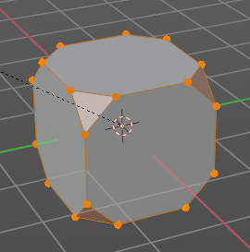
Bevel Vertices
Adds a bevel at the selected vertices.

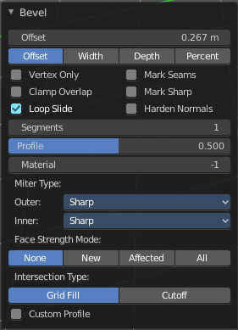
Last Operator Bevel

Offset
The Bevel amount. This text changes, dependent of the chosen width type.

Width type
Which measure type to choose for the bevel action. Offset, Width, Depth or Percent.

Vertex only
Bevel Vertices only.

Clamp Overlap
Do not allow beveled geometry to overlap each other.

Loop Slide
Prefer slide along edge to even widths.

Mark Seams
Mark the edges of the new created geometry as seams.

Mark Sharp
Mark the edges of the new created geometry sharp.

Harden Normals
When enabled, the per-vertex face normals of the bevel faces are adjusted to match the surrounding faces, and the normals of the surrounding faces are not affected. This will keep the surrounding faces flat (if they were before), with the bevel faces shading smoothly into them. For this effect to work, custom split normals need to be enabled, which requires Auto Smooth to be enabled (see Normals). As a convenience, that option will be enabled for you if it is not already when you enable Harden Normals here.

Segments
How many segments gets created.

Profile
Controls the Profile shape. 0.5 means round.

Material
Material for beveled faces. -1 is the surrounding material.

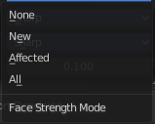
Miter Type

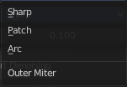
Outer Miter
How the outer miter is set. Miter is how the bevel rounding at a corner is done.


Sharp
Creates a sharp miter.

Patch

This replaces the outside vertex of a miter with 3 vertices. And uses a patch pattern there.

Arc

This replaces the vertex of a miter with 2 vertices, joined by an arc. A separate Spread parameter says how far to move the vertices away from their original position.

Inner Miter
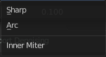
How the inner miter is set. Miter is how the bevel rounding at a corner is done.

Sharp
Creates a sharp miter.

Arc
This replaces the vertex of a miter with 2 vertices, joined by an arc. A separate Spread parameter says how far to move the vertices away from their original position.

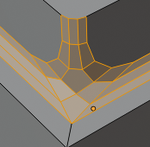
Spread
Belongs to inner miter method Arc. Adjust how strong the inner radius is bent.

Face Strength Mode
Set Face Strength on the faces involved in the bevel, according to the specified mode. This can be used in conjunction with a Weight Normals Modifier (with the Face Influence option checked).

None
Do not set face strength.

New
Set the face strength of new faces along edges to Medium, and the face strength of new faces at vertices to Weak.

Affected
In addition to those set for the New case, also set the faces adjacent to new faces to have strength Strong.

All
In addition to those set for the Affected option, also set all the rest of the faces of the model to have strength Strong.

Intersection type
The method to use to create meshes at intersections. Bevel can create self intersecting geometry.

Make Edge/Face
Adds a face when you have edges selected. And Edges when you have Vertices selected. It's a Bridge tool.
You can have either the one method or the other. When you select two adjacent vertices, then you select the edge too. And the tool works in edge mode then. In this case just the possible faces gets created. Not edges between single vertices.
First select the edges or Vertices that you want to bridge. Then click the New Edge/Face from Vertices Button.
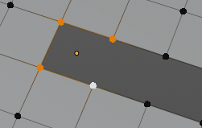
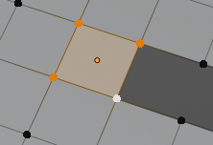
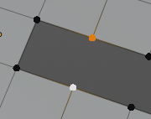
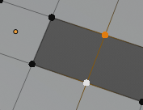

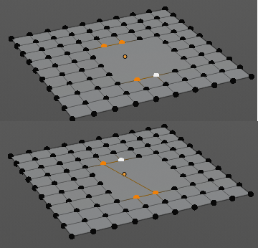
Connect Vertex Path
Connect Vertex path connects selected vertices, but takes the vertex order into account in which you selected the vertices. It just creates edges between vertices that are not connected in this order.

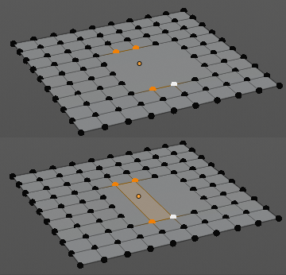
Connect Vertex Pair
Connect Vertex pair connects selected vertices and makes a face of the pairs.

Push/Pull
It pushes or pulls the object positions relative to the center of the selection.
In Object mode this tool requires to have more than one object selected.


Last Operator Push/Pull

Factor
Adjust the strength of influence of the tool.

Proportional editing
Enables proportional editing. Activating proportional editing reveals further settings.

Proportional Falloff
Adjust the falloff methods.

Proportional Size
See and adjust the falloff radius.

Connected
The proportional falloff gets calculated for connected parts only.

Projected(2D)
The proportional falloff gets calculated in the screen space. Depth doesn't play a role. When it's in the radius, then it gets calculated.

Shrink/Fatten
Shrink/Fatten scales the selected geometry along its normals. Transform orientation and Pivot point gets ignored.
A positive value pushes the vertices outwards. A negative value pushes the vertices inwards.


Last Operator Shrink/Fatten
The Last Operator Shrink/Fatten panel gives you tools to adjust the Shrink/Fatten operation. Here you have numeric input for the strength and a few more options.

Offset
Offset is the strength of the offset for Shrink/Fatten.

Offset Even
Offset Even scales the selection to give more thickness in even areas.

Proportional editing
Enables proportional editing. Activating proportional editing reveals further settings.

Proportional Falloff
Adjust the falloff methods.

Proportional Size
See and adjust the falloff radius.

Connected
The proportional falloff gets calculated for connected parts only.

Projected(2D)
The proportional falloff gets calculated in the screen space. Depth doesn't play a role. When it's in the radius, then it gets calculated.

Shear
Shear shears the selection.


Last Operator Shear

Offset
Adjust an offset.

Shear Axis
The shear tool works along a imaginary 2d plane. The shear axis controls if the items are sheared along the x or the y axes of this plane. This is the plane along which the transformation happens. You can shear along the x or the y axis of this plane.
To make things even more complicated, the orientation of this imaginary plane is defined by the Axis and Axis Ortho items below.

Axis
Defines one axis of the imaginary shear axis plane.

Axis Ortho
Defines the other axis of the imaginary shear axis plane.

Orientation
Choose the orientation for the shear action.

Proportional editing
Enables proportional editing. Activating proportional editing reveals further settings.

Proportional Falloff
Adjust the falloff methods.

Proportional Size
See and adjust the falloff radius.

Connected
The proportional falloff gets calculated for connected parts only.

Projected(2D)
The proportional falloff gets calculated in the screen space. Depth doesn't play a role. When it's in the radius, then it gets calculated.

Randomize Vertices
This tool allows randomizes the positions of the selected vertices.


Last Operator Randomize

Amount
Adjust the amount.

Uniform
The uniform offset distance.

Normal
Align the offset direction to the normals.

Random Seed
The seed value for randomization.

Smooth Laplacian
Laplacian Smooth Vertex smooths out the angles between the selected vertices. It is a tool to reduce noise at the mesh. It works a bit different than the normal Smooth Vertex tool. And gives a different result. The Laplacian method allows you to preserve the volume, and to adjust border smoothing.

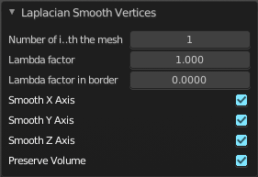
Last Operator Laplacian Smooth Vertex

Number of Iterations
Number of Iterations is the number of iterations that the smoothing action gets repeated. With 1 the smoothing is just performed once. With 10 it is performed ten times.

Lambda Factor
Lambda Factor is the strength of the smoothing.

Lambda Factor in border
Lambda Factor is the strength of the smoothing in border areas.

Smooth Axis
The Smooth Axis check boxes allows you to limit the smoothing to specific world axis.

Preserve Volume
Preserve Volume preserves the volume of the object.


Snap Vertices
Choose several methods to snap one element to another. The menu items should be self explaining.

Last Operator Snap

Some snap operations shows a last operation panel, some not.

Offset
If the selection should snap as a whole, or if each individual element of the selection should snap.

Mirror Vertices
Mirror by hotkeys. You activate the tool, type in x for x global for example, or x x for x local. And the selection gets mirrored.

Last Operator Mirror

The Last Operator Mirror panel gives you tools to adjust the mirror action.

Orientation
Orientation is a drop-down box choose the type of orientation for the mirroring action.

Constraint Axis
Constraint Axis gives you again the possibility to define the mirror axis. You can choose more than one axis here.

Proportional editing
Enables proportional editing. Activating proportional editing reveals further settings.

Proportional Falloff
Adjust the falloff methods.

Proportional Size
See and adjust the falloff radius.

Connected
The proportional falloff gets calculated for connected parts only.

Projected(2D)
The proportional falloff gets calculated in the screen space. Depth doesn't play a role. When it's in the radius, then it gets calculated.

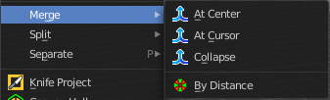
Merge Vertices
Merges the geometry.

At Center, At Cursor, Collapse
Merges the geometry with the given methods.

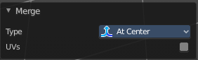
Last Operator Merge

Type
Choose the merge method again.

UV's
Move the UV's according to the merge.

By Distance
Merge the vertices by their distance to each other. This tool is meant to remove double vertices at the same location.

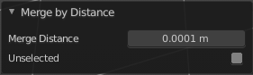
Last Operator Merge by Distance

Merge Distance
Adjust the distance below which the vertices gets merged.
Merge selected vertices to unselected vertices.

Split
Splits the edges between the selected vertices. It creates two edges out of one. And splits the edge by that.

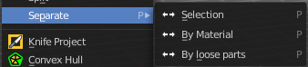
Separate
Separate separates the selected geometry, and creates a new object. The geometry becomes uneditable, since it is now a new object. You will have to leave the Edit mode, select the new object, and re-enter Edit mode when you want to edit it.

Selection
Selection separates the current selection.

By Material
By Material separates all geometry that has the same material than the current selection.

By Loose Parts
By Loose parts separates all geometry that is connected by edges to the current selection.

Dissolve Vertices
Dissolve Vertices dissolves the selected Vertices.
Note that pressing DEL in Vertice select mode calls Dissolve Vertices already. It's the same operator. But you don't get the Last operator that way.

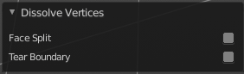
Last Operator Dissolve Vertices

Face Split
Split off Face corners to maintain surrounding geometry

Tear Boundary
Split off Face corners instead of merging faces.

Delete Vertices
Deletes the selected vertices.

